**BDAT 1001 Thursday Information Encoding Standards** **Name**: Shubham Chawla

*Assignment 1* **Student ID**: 200493036

The original code has been modified as stated below:

**Task 1**

Take user input for their **Full Name** as well as their **Birth Month**. User would have to enter 1 for Full Name Conversion and 2 for Birth Month conversion. The string entered (1 or 2) was converted to Int using **‘int.parse’** method.

Used a do while loop to encase the **Program.cs** code to allow to user to restart the program from the console itself by entering ‘y’



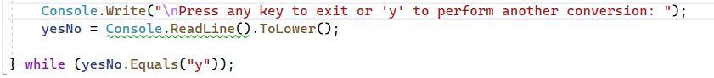

**Task 2 – Binary Encoding and Decoding**

Modifications were done to the loop structure from foreach to for. Used String Array indexing.



**Task 3 – Hexadecimal Encoding and Decoding**

Modifications were done to the loop structure from foreach to for. Used String Array indexing.

**Task 4 – Base64 Encoding and Decoding**

Ternary Operator was used instead of standard if-else ladder, which reduced the size of the code.



Used ternary operator again to minimize the code lines.



**Task 5 – Encryption and Decryption**

Used Unicode Encoding method.



**Output Full Name and Birth Month Conversion in continuation.**

**Input1: Shubham Chawla, Input2: April**

User chose full name conversion in the first case by entering ‘1’ and then they entered ‘y’ to perform another conversion where they chose birth month conversion by entering ‘2’. The output is in continuation.

